**PRN: 085 Rupesh Kamble**

**These are some of snippets of procedure followed to Host “Northwind” Website**

1. **Git Repository :**

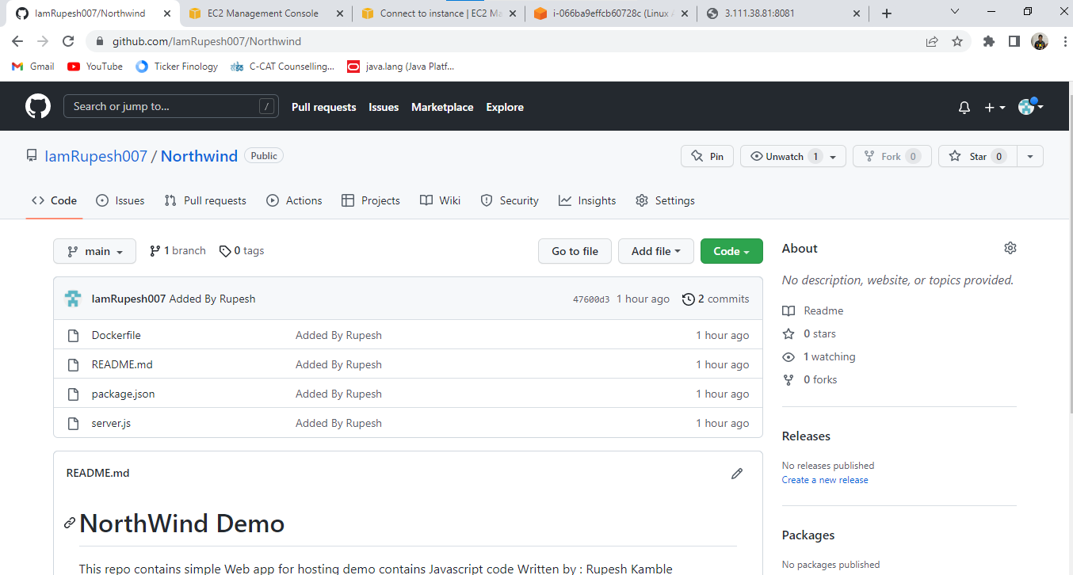

1. **AWS Server :**

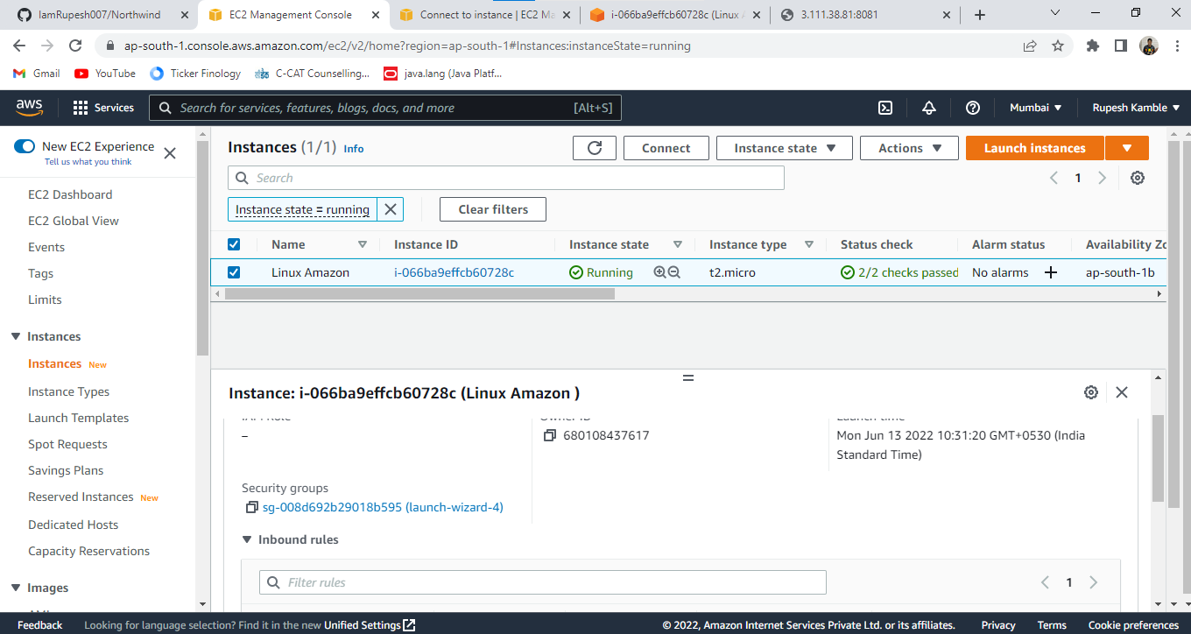

1. **Clone GitHub Northwind code repository to your Developer machine using git command**

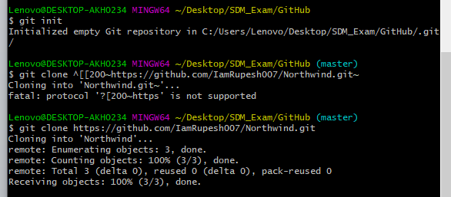

1. **Runnning Docker :**

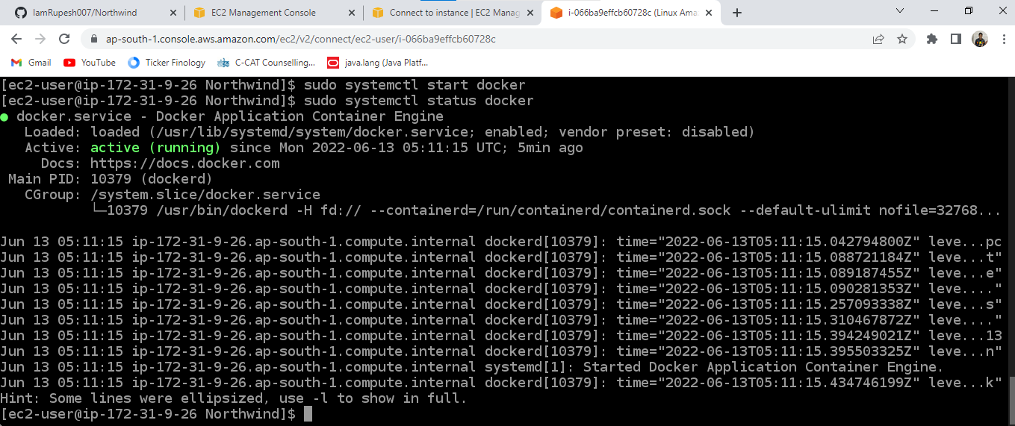

1. **Container instances running using docker on linux virtual**

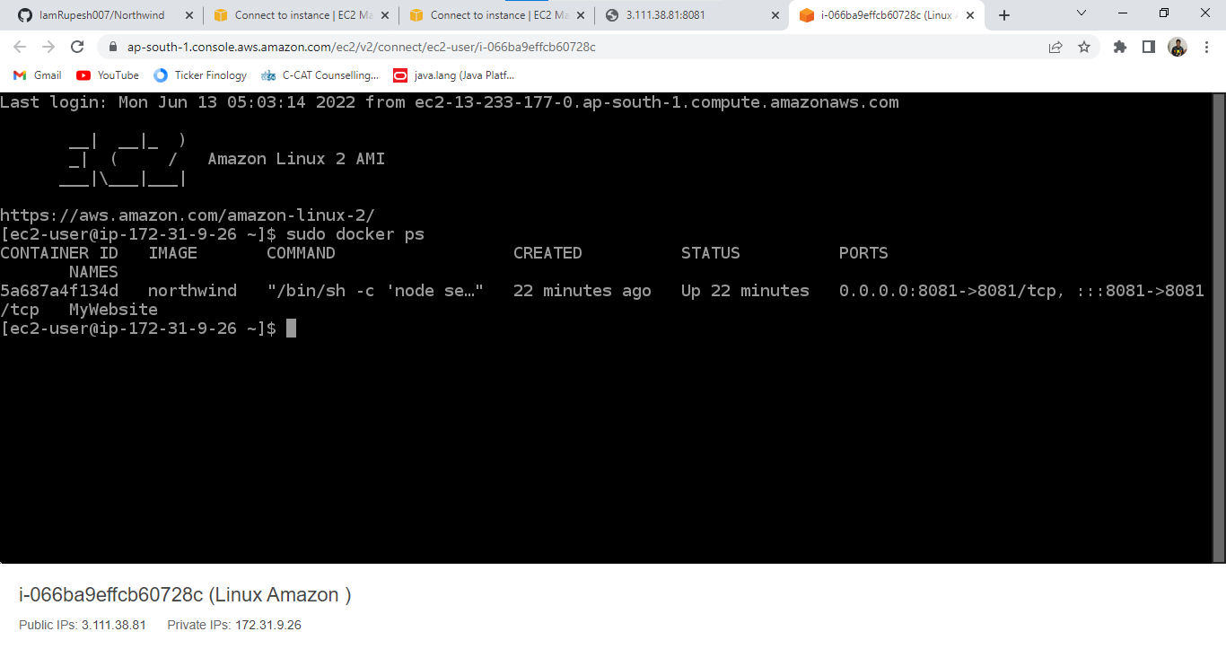

1. **Hosted website:**

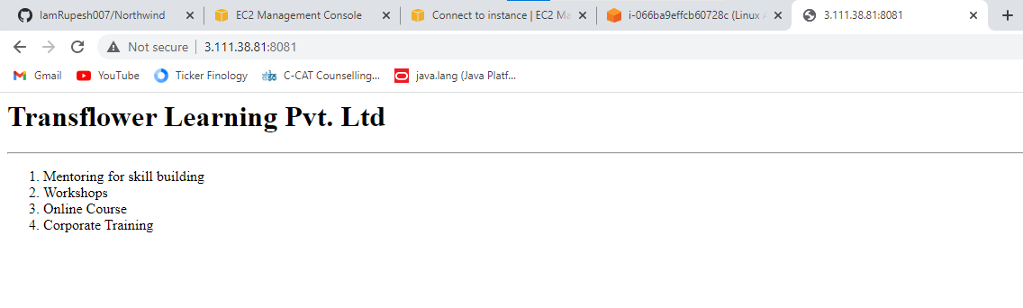

**Thank You!**